Remote Sensing of Canadian Boreal Forest Fires: Hotspots, Burned Area, and Smoke Plumes

Z. Li†, J. Cihlar

Canada Center for Remote Sensing, 588 Booth St., Ottawa, ON, Canada, K1A 0Y7
†Tel: (613) 947-1311; Fax: (613) 947-1406; E-mail: zhanqing.li@geocan.nrcan.gc.ca

R.H. Fraser, A. Khananian
Intermap Technologies Ltd., 588 Booth St., Ottawa, Ontario, Canada, K1A 0Y7

Abstract—A comprehensive investigation of Canadian boreal forest fires was conducted using NOAA-AVHRR. Algorithms were developed for detecting active fires (hotspots), burned areas, and smoke plumes, which employ single images and 10-day Normalised Difference Vegetation Index (NDVI) composites. The hotspot algorithm was applied to four years (1994-97) of imagery, producing a daily fire mask for Canada. Almost all fire events were detected, but cumulative hotspot area was significantly smaller (~30%) than burned area reported by fire agencies. To provide more accurate estimates of burned area, a burn mapping algorithm was developed that synergistically combines the hotspot product with anniversary date NDVI composites. The hybrid technique produced estimates of Canada-wide burned area that were within 5 percent of official statistics. A neural-network classifier was also developed that allows smoke plumes to be effectively separated from cloud cover at a regional scale.

INTRODUCTION

Canadian forests encompass 4.2 million km², representing more than 10 percent of the world’s forest cover. The majority of Canadian forest lies in the boreal zone, which is subject to extensive periodic burning. On average, 9,000 fires burn more than 2 million ha of Canadian forest each year. Wildfires are a dominant influence on the boreal forest, controlling vegetation successional patterns, carbon cycling, and ground thermal regimes [1]. Large quantities of greenhouse gases and smoke aerosol emitted by fires also affect the radiation budget, and are thus important parameters for global climate modeling [2]. Due to the widespread extent and remoteness of boreal fires, satellite remote sensing is particularly well suited to identifying active fires and to measuring the extent of burning so that these impacts may be assessed. This paper presents a summary of fire research activities conducted since 1995 by scientists from the Canada Centre for Remote Sensing (CCRS) and industry.

SATELLITE DATA

The CCRS fire algorithms are founded on imagery from the advanced very high resolution radiometer (AVHRR) aboard NOAA-11 (1994) and NOAA-14 (1995 onward). The local overpass time of NOAA-11 in Canada was around 15:45 with a viewing geometry close to the principal plane, i.e. the AVHRR sensor scanned the earth in either backward or forward scattering direction. NOAA-14 has an earlier overpass time (13:00 LT in 1995 and somewhat later in subsequent years) with a viewing plane 45º relative to the principal plane. All AVHRR data were received at the Prince Albert station receiving station in Saskatchewan, then calibrated and geo-referenced using the geocoding and compositing (GEOCOMP) system [3]. Calibration for visible (ch1) and near-IR (ch2) measurements from NOAA-11 employed time-dependent offset and gain values [4], while that for NOAA-14 was based on values recommended by Rao and Chen [5]. The thermal AVHRR channels (3-5) were calibrated using onboard blackbody reference. Canada-wide composites are registered to Lambert Conformal Conic projection using an orbit model and high-resolution LANDSAT image chips, typically yielding a positional accuracy better than 1km.
Single day GEOCOMP composites were further processed using the ABC3 methodology (atmospheric, bidirectional, and cloud contamination corrections of CCRS) [6]. For Channels 1 and 2, ABC3 computes top-of-atmosphere reflectance, performs atmospheric corrections, and corrects for bidirectional reflectance effects. Cloud contaminated pixels are replaced by linearly interpolating the seasonal trajectory of each channel for that pixel. The NDVI is then calculated from corrected reflectances, and smoothed in the temporal dimension to obtain a value for each pixel every 10 days during the growing season.

HOTSPOT DETECTION

A fire detection (hotspot) algorithm was developed that exploits the infrared channels (2-5) from AVHRR [7]. The algorithm is based on the framework of Kaufman et al. [8] with modifications for the NOAA-14/AVHRR sensor. New tests are also introduced to account for the unique environmental and wildfire characteristics of boreal forests. The algorithm consists of two major steps: marking potential fire pixels using the strong thermal signal in the mid-infrared channel (3.7 μm), then removing false fires using a series of threshold tests (Fig.1). Threshold tests were optimised to detect the majority of real fires, while removing as many false fires as possible. Thresholds were chosen following a trial-and-error approach based on a 1,200 by 1,200 km training data set. Histogram analyses of reflectance and brightness temperature corresponding to burning and non-burning pixels provided an effective means of obtaining optimised values.
The hotspot algorithm was applied to archived single-date GEOCOMP composites for the years 1994-1997, producing a daily fire mask for all of Canada. In summer, 1998, the algorithm was applied operationally. Images showing active fires and smoke were generated within 24 hours of satellite reception, and sent to Canadian fire management agencies and media. Comparing the 1994 and 1995 hotspot locations to provincial fire surveys, the algorithm was found to detect the vast majority (> 90%) of fires larger than 300 ha. Within individual burns, however, the distribution of hotspots is patchy due to limited satellite revisit frequency and obscuring by cloud (Fig. 2). Consequently, the cumulative area of all hotspot pixels detected during each summer was, on average, about 30% less than estimates based on traditional reconnaissance. To account for these missed burned patches, a novel burned area mapping technique was proposed.

BURNED AREA DETECTION

Various change detection techniques have been applied in an attempt to derive more accurate estimates of burned area than is possible from hotspot detection. One such technique involves computing the difference between anniversary date (spring or fall) NDVI composites, then establishing a threshold suitable for separating any fresh burns [9-10]. Although NDVI differencing can successfully discriminate most burned areas, it is also prone to detecting false burns due to NDVI decreases unrelated to fire (e.g., from drought, harvesting, or cloud contamination). Furthermore, it is difficult to derive a threshold that is effective over large, heterogeneous regions such as the Canadian boreal forest.
To overcome these difficulties, a new technique was developed for burned area mapping that synergistically combines output from the hotspot algorithm with differencing of anniversary date NDVI composites produced from the ABC3 procedure [11]. The algorithm, abbreviated HANDS (Hotspot and NDVI Differencing Synergy), uses annual hotspot locations to derive a spatially variable difference threshold for separating burned areas (Fig. 3). A coarse, regional threshold is first applied, followed by a more restrictive local threshold. The local threshold is derived for individual burn patches, which are isolated using GIS clumping techniques. The final product requires burned patches to be spatially coincident with detected hotspots.
The mapping technique was applied to Canadian forest for the 1995 and 1996 fire seasons. National burned area was calculated to be 6.8 million ha in 1995 and 2.0 million ha in 1996, comparing favorably to Canada Forest Service estimates of 7.1 and 1.9 million ha, respectively. Moreover, at local scales, HANDS burns closely corresponded to individual burn polygons derived from aerial surveys (Fig. 2).

SMOKE DETECTION

Smoke aerosol emanating from forest fires is often difficult to visually distinguish from cloud cover using AVHRR false-colour composites. A neural network classifier was thus employed that allows separation of smoke from cloud based on subtle differences in their reflectance and emission. This artificial intelligence approach was found to be generally more adaptive and accurate compared to traditional multi-channel thresholding. The technique was successfully applied at a regional scale to a number of AVHRR scenes characterized by heavy smoke cover.

SUMMARY

A suite of boreal fire detection algorithms was developed that exploits the multi-channel information and daily Canada-wide coverage provided by NOAA-AVHRR. An AVHRR processing chain and hotspot algorithm are now ready for operational application during the summer fire season, allowing fire images to be distributed within 24 hours of satellite reception. At the end of the fire season, accurate measurements of burned area can be produced using a new hybrid technique that combines an annual hotspot mask with anniversary date NDVI composites.

REFERENCES

[1] N.H. French, E.S. Kasischke, R.D. Johnson, L.L. Bourgeau-Chavez, A.L. Frick, and S. Ustin, “Estimating Fire-Related Carbon Flux in Alaskan Boreal Forests using Multisensor Remote-Sensing Data,” in Biomass Burning and Global Change. J.S. Levine, Ed. Cambridge:MIT Press, 1996, pp. 808-826.
[2] J.S. Levine, W.R. Cofer, D.R. Cahoon, and E.L. Winstead, “Biomass Burning: A Driver for Global Change,” Environ. Sci. & Tech., vol. 29, pp. 120-125, 1995.
[3] B. Robertson, A. Erickson, J. Friedel, B. Guindon, T. Fisher, R. Brown, P. Teillet, M. D’Iorio, J. Cihlar, and A. Sancz, “GEOCOMP: a NOAA AVHRR geocoding and compositing system,” in Proceedings of the ISPRS Conference, Commission 2, Washington, D.C., pp. 223-228, 1992.
[4] J. Cihlar, and P.M. Teillet, “Forward piecewise linear calibration model for quasi-real-time processing of AVHRR data,” Can. J. Remote Sens., vol. 21, pp. 22-27, 1995.
[5] C.R.N. Rao, and J. Chen, “Post-launch calibration of the visible and near-infrared channels of the Advanced Very High Resolution Radiometer on NOAA-14 spacecraft,” Int. J. Remote Sens., vol. 17, pp. 2743-2747, 1996.
[6] J. Cihlar, H. Ly, Z. Li, J. Chen, and H. Pokrant, “Multitemporal, multichannel AVHRR Data Sets for Land Biosphere Studies: Artifacts and Corrections,” Remote Sens. Environ., vol. 60, pp. 35-57, 1997.
[7] Z. Li, S. Nadon, and J. Cihlar, “Satellite detection of Canadian boreal forest fires part I: algorithm development and application,” unpublished.
[8] Y. Kaufman, C. Tucker, and I. Fung, “Remote sensing of biomass burning in the tropics,” J. Geophys. Res., vol. 95, pp. 23,851-23,863, 1990.
[9] E.S. Kasischke, and N.H. French, “Locating and estimating the areal extent of wildfires in Alaskan boreal forests using multiple-season AVHRR NDVI composite data,” Remote Sens. Environ., vol. 51, pp. 263-275, 1995.

Figure 2. Region in Saskatchewan that was subject to several large burns in 1995. Hotspots detected using the fire detection algorithm are shown in dark gray. Burned areas not detected as hotspots but mapped using the HANDS burn mapping algorithm are shown in light gray. The outer burn boundaries mapped by the province are also shown.
[10] Z. Li, S. Nadon, B. Stocks, and J. Cihlar, “Satellite detection of Canadian boreal forest fires part II: algorithm validation and comparison,” unpublished.
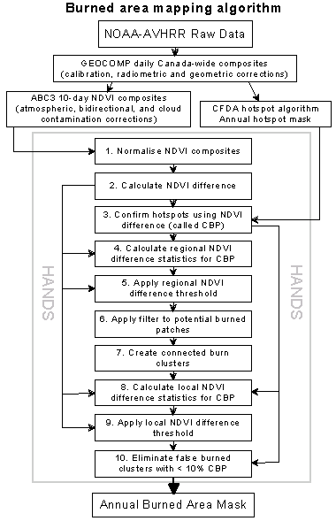
[11] R.H. Fraser, Z. Li, and J. Cihlar, “Hotspot and NDVI Differencing Synergy (HANDS): a New Technique for Burned Area Mapping,” unpublished.
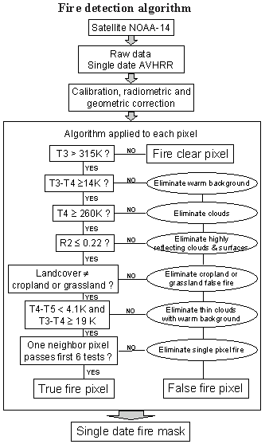
Figure 1. Flowchart of processing steps required for the NOAA-14 fire detection algorithm

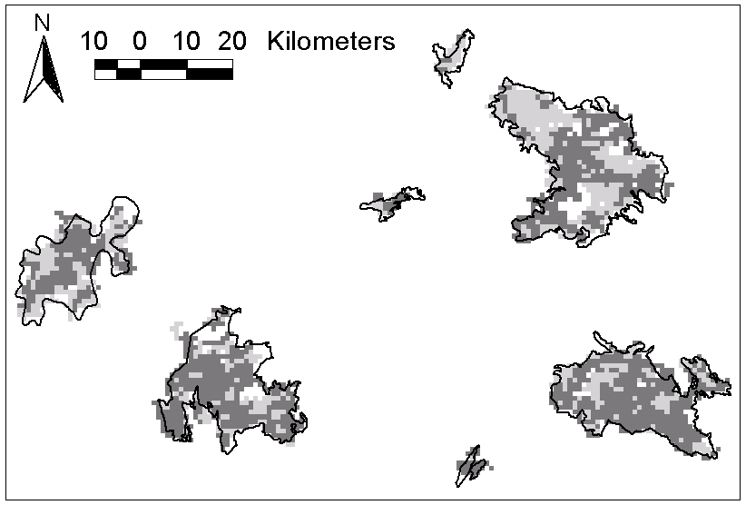
Figure 3. Flowchart of processing steps required for the burn mapping algorithm

Presented at IEEE 1999 International Geoscience and Remote Sensing Symposium

